Thammenenwar Swathi
+91 9390961523 swathithammenenwar@gmail.com

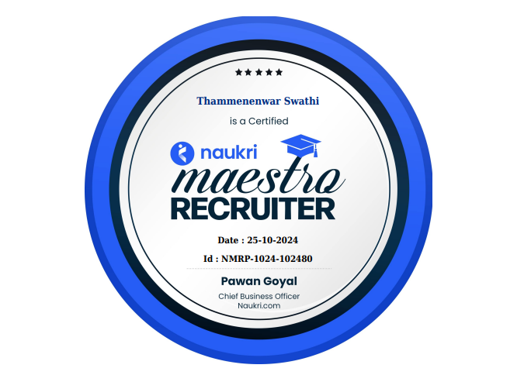
CAREER OBJECTIVE:

Goal-oriented, Recruiting management with 3.3 Years of experience in IT Recruitment in various range of industries. To secure a challenging position in a reputable organization to expand my learnings, knowledge and skills.

Recruitment Skills:

- Candidate Sourcing & Screening
- Employee Referrals
- Advanced Boolean Searches
- Offer Negotiations
- Placement & On-boarding

Certifications:
I received Award of Excellence for the 1st Quarterly target of 2023 AS MOST DETERMINED EMPLOYEE

Professional Summary:

- Having a total 3.3 years of progressive experience in End to End IT Recruitment.
- Good working knowledge in HR functions like Sourcing Resumes, Screening, Mass mailing, Job postings and Internet based tools (Job Sites) specially trained on Monster, Naukri and Internal Database, Personal references.
- Good experience in Searching appropriate consultant using social media sites like, LinkedIn, Shine.
- Outstanding persuasion, negotiation and investigative skills with ability to work effectively in high- pressure environments.
- Strong interpersonal and communication skills, creativity, excellent attitude towards teamwork and common goals achievement.
- Able to work as an individual as well as in team Detail-oriented and resourceful in meeting targets Flexibility of working on different platforms and good flare for learning new technologies.

Company Name: SP Software pvt limited Aug 2022- till date

Designation : Recruiter Job Responsibilities :
- Handling End to End Recruitment process.
- Briefly Understanding the requirements received from clients.
- Looking after the entire cycle of recruitment that includes headhunting, searching, sourcing potential candidates.
- Short-listing resumes by evaluating the candidate’s communication skills, presentation and technical skills based on the client’s requirements.
- Cold calling the candidates and discuss about the job opportunities, location, clients and employment type with the candidates.
- Screening and short listing the profiles according to JD from job portals and sharing the profiles to clients.
- Scheduling interviews like telephonic, Face to Face and Walk in Interviews to the candidates after short listed.
- Negotiating & convincing candidates to accept the offer and make them join in short notice as soon as possible.
- Building good relations with the candidates and maintaining the database. Developed recruiting Strategies to identify qualified candidates and build network.
- End- to- End follow-up with candidates since after shortlisted for interviews and till joining date.
- Preparation of Weekly and Monthly report relating to Interviews with number of interviews happened, Offer Made and Candidates Joined.
- Involved in HR Operations for onboarding and exit formalities.

Technologies Handled:

- Web Technologies: Core Java, J2EE, Web Services, JSP, JDBC, Struts, Hibernate, spring,
- Testing: Manual, Automation Testing, Selenium, API Testing.
- Cloud Technologies: AWS, Azure Cloud,
- Data Base: Mysql, sql, postgre, Oracle
- CRM: Salesforce

ACADEMIC PROFILE:

Osmania University| 2024-Pursing
Masters of Business Administration

Osmania University| 2019-2022
BSC-MSCs

DECLARATION:
I hereby declare that all the information furnished above is true and correct to the best of my knowledge.

Place : Hyderabad
Date :

